Healthcare Administration (Panama)
Authors Name
Institutional Affiliation
Date of Submission

Abstract
Healthcare plays an important in ensuring that people within a particular society or even states live well and most importantly provide that they live healthy thus able to effectively and successfully achieve their objectives in general. Therefore, healthcare administration will ensure that healthcare organizations are managed effectively and most importantly providing that they will be able to effectively and successfully achieve their goals and objectives in general. Healthcare administration entails leadership, management and most important successful administrations of systems related to the public system, hospital and their networks and any other healthcare-related systems in general. Therefore, it can be used to describe leadership and general management of healthcare-related organizations and systems.
The role of healthcare management, in this case, is to ensure that particular outcomes will be achieved and most importantly ensure that department within health facilities are running smoothly and most important towards achieving their goals and objectives in general. Other than that, it focuses on providing right individuals for right jobs and most important those who understand what their responsibilities are to achieve the goals of improving healthcare services, outcomes and also the health sectors in general. In consideration to recent years, Panama has seen significant improvement in attention to their health sector (Raez, Cardona, Santos, Catoe, et al., 2018). Health administrators in this case are facing new tasks that requires them to adequately address different forms of challenges that has continued to affect the healthcare sectors particularly in Panama in consideration to the necessary capacity and most important addressing the needs of personnel shortages and the same time focusing on directing Panama through transitions that will help to effectively prevent focuses healthcare related models in general.

Healthcare Administration (Panama)
Introduction
Panama is a country in Central America with its capital city being Panama City. It has five different ethnic groups that include Mestizo, White Panamanian, Native Panamanians, Mulatto, and also the Afro-Panamanian. Its government is a unitary presidential constitutional republic. Panama’s geographical area is approximately 75,417 km2 with water bodies covering about 2.9 percent of its territory (Hobbs, 2016). Its populations are estimated to be around 4,034,119 people thus resulting in a density of 56/km2. The official language in consideration to Panama is mainly Spanish although a large group of people in this country is Bilingual with English being considered the most common language among people within this country in general.
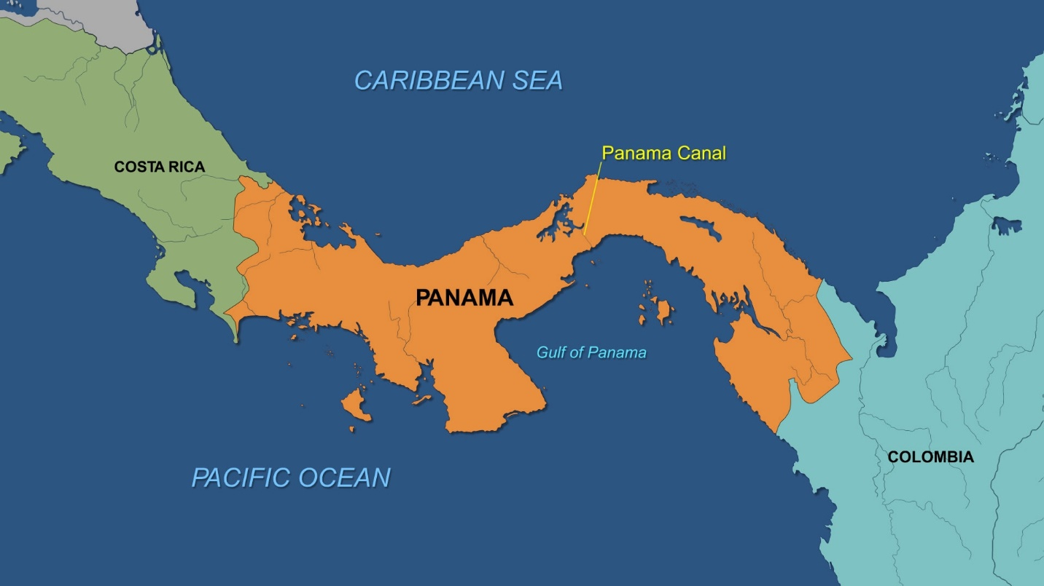
Source https://news.cgtn.com/news/3d49444e3349444e/share_p.html
Like any other state, Panama has people that need and require quality health and those that will help to eliminate most of their health issues and most importantly ensure an improved health sector in general. Typically, the healthcare sectors play a more significant role in providing that a country would be productive and most importantly ability to move effectively towards its objectives, goals, and achievements particular healthy and productive states through the people that are involved and most importantly ensuring that the country will be able to be productive in different areas. Typically, citizens not only in Panama but also in other state need good services and management when it comes to ensuring that the health conditions are improved and providing that they will be active and significant in enhancing productivity and success in consideration to most of the activities that these people engage in general (Villarreal, Turner, Jo, Park, Gemmen, et al., 2017). With a good healthcare system, Panama has been active when it comes to its economy and development of other areas in general.

Health Indicators
The current birth rate for Panama for approximately one thousand people is 20.6 with the price expected to decreases with years in general. In consideration to the World Health Organizations, Panama’s life expectancy is mainly 75.0 for the male and 81.2 for the female. This data translated to a total life expectancy of 78.0. As a result of this data, Panama is ranked 38th in position in consideration to the world’s life expectancy ranking general (Foreman, Marquez, Dolgert, Fukutaki, et al, 2018). The death rate for the country is mainly 5 per one thousand population of people. The most leading cause of deaths in Panama is considered as being coronary heart disease followed by stroke and diabetes mellitus.

Panama’s Birth Rates
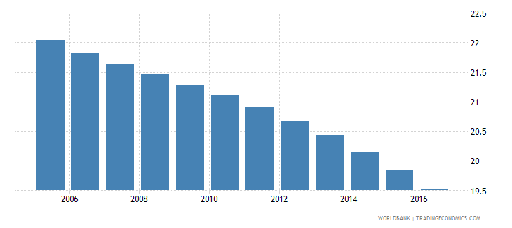
Healthcare System
Panama has focused on developing a good healthcare system one that would be effective and able to ensure that people have been satisfied with the services they get from the healthcare system in the country in general. Both private and government sectors are involved in providing these services for most of their members in general. In this case, the private sectors are mainly funded through Misterio de Salud and most important the social security fund which will help to operate activities and operations of these firms in general. Private expenditures are about forty percent of the healthcare spending in total which in most cases if directly from people’s pocket spending in general (Sánchez, Berbey, de la Torre-Díez& López-Coronado, 2017).
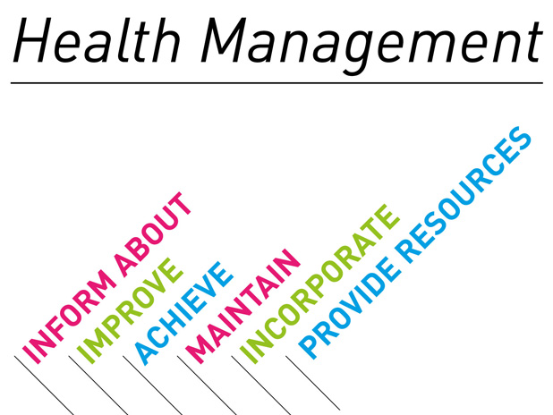
For most of the emergency medical services, they are mainly done in Panama City where the services of 911 are available. Costs of healthcare play an essential role in ensuring that people will be able to successfully and effectively receive medical services with less consideration of money. In this case, prices of healthcare services in the account to Panama are generally lower to those of the United States and most of the highly developed states. Most of the healthcare providers, in this case, have been trained highly particularly in the United States but only a few of them can be considered as board-qualified. Other than that, others are also educated in medical schools that are of high quality in different states that include Panama, Mexico, and even Spain (Raez, Cardona, Santos, Catoe, et al., 2018). It has provided the country with enough healthcare medical personalities that provide quality healthcare and improved services thus able to ensure effectiveness in consideration to the healthcare system of Panama.
Most of the public hospitals are funded mainly by the ministry of health and social security system provide people without the ability to access services from private sectors to effectively access services that are of high quality and those that will ensure that their health issues have been dealt with effectively and successfully in general (Foreman, Marquez, Dolgert, Fukutaki, et al, 2018).Therefore, Panama has been effective in ensuring that its people can access quality healthcare services and most important those that will provide significant changes in catering for the needs and objectives of their customers in general.
Healthcare in Panama vs. the United States
The United States is highly and one of the most developed states in the whole world. On the other hand, Panama is not as powerful as the United States in consideration of different factors and consideration including healthcare system and the economy. One of the best element when considering healthcare sector in Panama is the fact that its costs of healthcare services are lower compared to those of the United States (Sánchez, Berbey, de la Torre-Díez& López-Coronado, 2017). But the united states have developed in technology, education sectors, particularly in medical educations, thus providing it with a chance to of better quality of healthcare services than those from Panama and other states in general. Although the quality of healthcare services is high in Panama, it is not the same as that form the United States in general. As a result, Panama has sought to improve its healthcare personnel through educations from developed states one of them being the United States in general. Fundamental procedures of treating people in Panama will cost from 3-4 less than costs offered in the United States.

Quest for Healthcare in different states
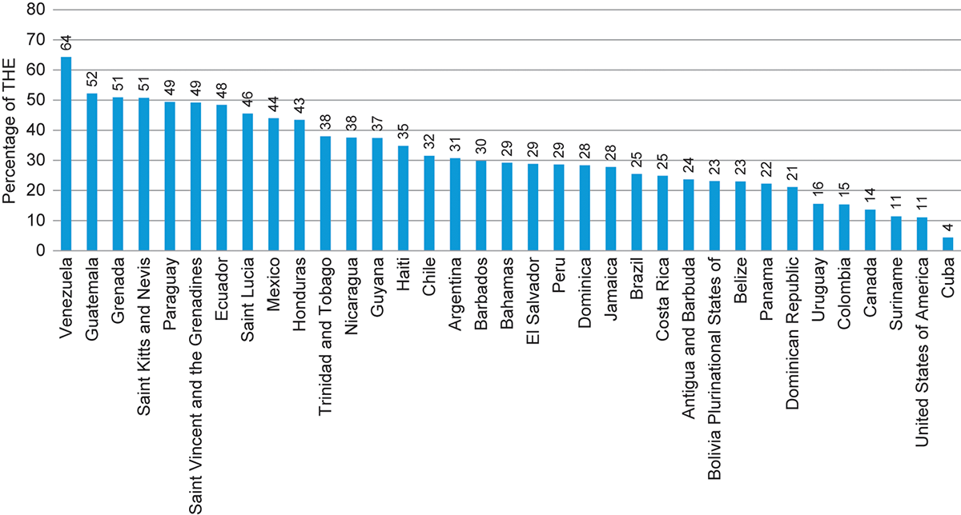
Source; https://www.paho.org/salud-en-las-americas-2017/?p=65
Health insurances are also affordable in Panama. Typically, Panama offers plans that range from form basic coverage to full coverage and most important other advanced care of medical allowing people to easily be able to cover for a variety of their needs and most essential budgets in general (Sánchez, Berbey, de la Torre-Díez& López-Coronado, 2017). When considering the US, the risks of not having health insurance can be viewed as being lower. The primary reason, in this case, is the fact that procedural costs that have been insured are meager when they have been compared to typical budgets that are an expat or even fixed income.
Challenges facing the health Sector in Panama
The critical problem that this country is facing is mainly addressing inequitable health access particularly for the poor and most important consideration of consolidation and scaling up incentives that are currently available for the state which hinders effectiveness, efficiency and most crucial sustainability on the long-run (Carpio & Santiago Bench, 2015). Typically, people from rural and poor societies will receive services that are of poor quality which hinders effectiveness in consideration to the health of these people and most important the general healthcare system.
Poverty, on the other hand, is another factor and challenging aspect when it comes to the health sector in Panama. Poverty hinders effectiveness in consideration of the operations of healthcare activities and most important access to these services. As a result, the outcomes and effects among people that are facing poverty as a problem tend to be negative thus hindering improvement and general consequences of services that the health sector in Panama offer and in one way or another (Carpio & Santiago Bench, (2015). Other than that, qualified and well-trained healthcare PR actioners are less thus affecting operations that they offer to their patients and most importantly how the most healthcare organizations work in treating particular health issues. Therefore, it has resulted in a slow and less effective industry in ensuring that the needs and objectives of patients have been cater for in one way or another. These problems are not only encountered by Panama but also other states that are not highly developed in general.
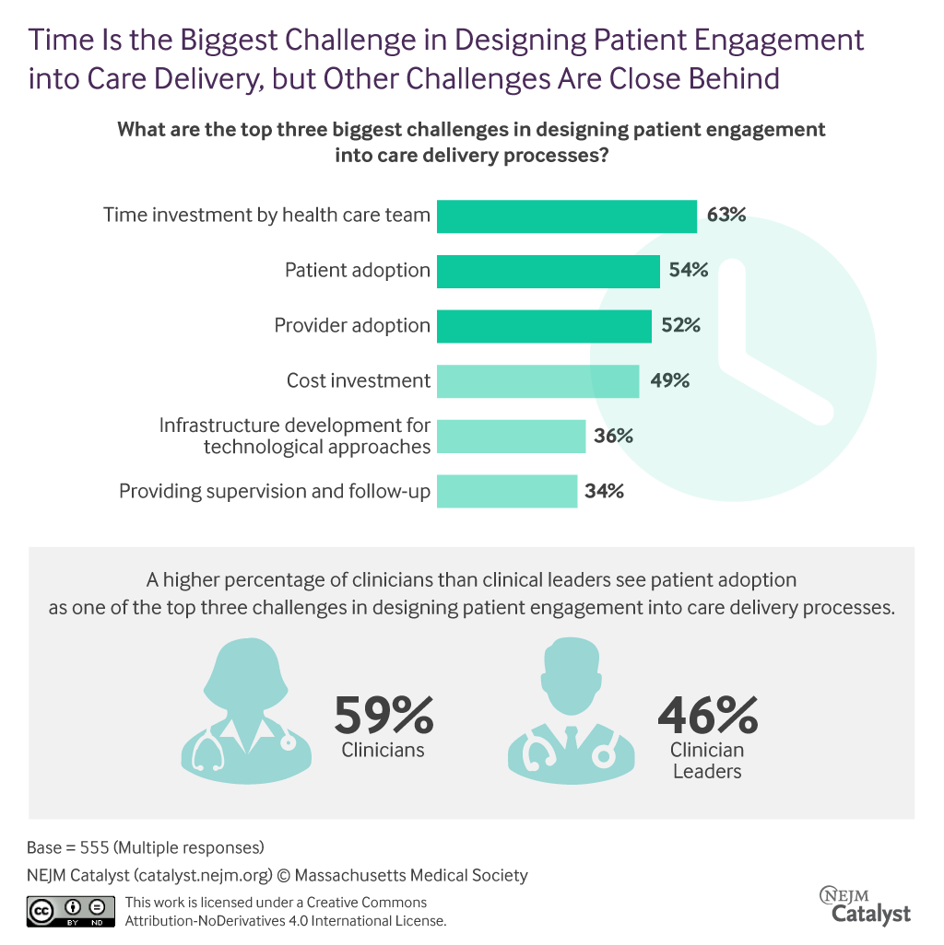
Source; https://catalyst.nejm.org/problems-patient-engagement-design/
The population is also another factor affecting people and most critical affecting ways in which they operate. Typically, Panama’s population has been a factor that affects the operations of these health facilities in general. Communities change ways in which delivery of health services in Panama thus affecting the general outcomes. It results in a lot of patients for a single health PR actioners which will change ways in which they perform their activities and how they conduct their operations in general (Raez, Cardona, Santos, Catoe, et al., 2018). Other than that, some problems include cardiovascular heart diseases and diabetes that has continued to affect people health results to high costs of treatments and also deaths in general. These factors have thus become challenges that affect the public health of people in Panama.
Contributions of the extent of these problems
Typically, most of this health care system is as a result of factors that can be related to the economy, social and also cultural aspects within the country. Typically, these factors have resulted in differences in consideration to how people live, how they access healthcare services and most important the impact that these services will have to different groups of people in general. They have resulted in the division of people in different groups which has significantly contributed to most of the problems that Panama and its health sector is facing.
The World Health Organizations focuses on promoting healthcare in different states to ensure that operations in health facilities and most crucial improving the delivery of health care services within these states. Groups of people within Panama has resulted in challenges tend to affect how people live and essential ways in which they access healthcare services. Unlike other states that are highly developed, Panama is still facing different challenges, and some of them are facing the health sector in one way or another general (Foreman, Marquez, Dolgert, Fukutaki, et al, 2018). Their population is a bit high making delivery of these services problems thus affecting how they impact the general services at distribution and most critical affecting ways in which they change the healthcare sector is concerned in general.
Concern for other states
There is an excellent role for states to consider and understand ways in which problems that Panama is facing in its healthcare sector and focus on a way that will ensure improvement. Typically, the effects of these problems may impact other states in one way or another (Carpio & Santiago Bench, 2015). Countries depend on each other for different needs and focus on benefits for the operations and relationships that they engage in general. As health play an important role in many states, any negative impact will significantly affect productivity and most important services with other nations. Therefore, there is a great need for the united states and other countries to understand and help eliminate a problem that Panama is facing in consideration to its healthcare industry which will help to improve their relationships and most importantly ensure productivity for the country thus having to benefit each other in one way or another.
Recommendations
The need to understand how Panama will improve its health outcomes is essential in ensuring effectiveness and significant changes in consideration to the country in general. In this case, believe that Panama can improve health outcomes by focusing on the problems that the sector encounters and ensuring that they eliminate them in one way or another. Poverty and poor access among people in some areas are significant issues (Carpio & Santiago Bench, 2015). In this regard, there is a great need to improve health access, quality and reduce costs of health care services in these areas. This case will eliminate the problem of inequitable access to health services and ensure an improved outcome in general. The primary focus should be on providing that people can access quality healthcare much easier, reliable and most important at a cost that is generally lower.
Health practitioners play a significant role in ensuring that quality and most critical improved services of the healthcare sector will be delivered as required to provide considerable change and outcomes in consideration to what they are offering. Therefore, there is a great need for Panama to consider improvements of their health sector through improving the number of qualified and most important those that will be capable of providing services that would satisfy the needs of patients in the entire states (Carpio & Santiago Bench, 2015). In this regard, the country needs to improve on its healthcare training institutions and ensure that they provide educations that would ensure effectiveness and significant changes and helping people through improvements of their health. The basis of improving the health sector should be to focuses on developing ways in which these services are provided and how operations, decisions, and management of health facilities will be considered in general.

References
Carpio, C., & Santiago Bench, N. (2015). The Health Workforce in Latin America and the Caribbean: An Analysis of Colombia, Costa Rica, Jamaica, Panama, Peru, and Uruguay. The World Bank.
Foreman, K. J., Marquez, N., Dolgert, A., Fukutaki, K., Fullman, N., McGaughey, M., ... & Brown, J. C. (2018). Forecasting life expectancy, years of life lost, and all-cause and cause-specific mortality for 250 causes of death: reference and alternative scenarios for 2016–40 for 195 countries and territories. The Lancet, 392(10159), 2052-2090.
Hobbs, J. J. (2016). Fundamentals of world regional geography. Cengage Learning.
Holtz, C. (2016). Global health care: Issues and policies. Jones & Bartlett Learning.
Raez, L. E., Cardona, A. F., Santos, E. S., Catoe, H., Rolfo, C., Lopes, G., ... & Caglevic, C. (2018). The burden of lung cancer in Latin-America and challenges in the access to genomic profiling, immunotherapy and targeted treatments. Lung cancer, 119, 7-13.
Sánchez, G. A. C., Berbey, A., de la Torre-Díez, I., & López-Coronado, M. (2017). Information and Communications Technologies Health Projects in Panama: A Systematic Review and their Relation with Public Policies. Journal of medical systems, 41(7), 110.
Villarreal, I., Turner, R., Jo, H., Park, J., Gemmen, E., Pirçon, J. Y., ... & Hausdorff, W. P. (2017). Healthcare-seeking behaviour of primary caregivers for acute otitis media in children aged 6 months to< 30 months in Panama: results of a cross-sectional survey. BMC pediatrics, 17(1), 3.

